

Waste Segregation System

**Team affiliation:**

22BCE8957 - SHRUTI GUGILWAR

22BEC7186 - SOURAV VIR SINGH

22BCE8204 - SHAMBHAVI GUNDA

22BCE9004 - AMAN YADAV

22BCE9167 - CHIRAG AGARWAL

22BCE9256 - SHRAWANI KULKARNI

University: Vellore Institute Of Technology, Amravati

Project: Engineering Clinics-I

Mentor: Dr Prof.Udit Narayana Kar

Date: 29th October 2023

**Introduction**

Waste segregation is the process of separating waste materials into different categories based on their composition. This is important for a number of reasons, including:

* To reduce the environmental impact of waste disposal. When waste is not properly segregated, it can end up in landfills, where it can decompose and release harmful gases into the atmosphere. Segregating waste allows for different types of waste to be disposed of in the most environmentally friendly way possible.
* To improve the efficiency of waste collection and recycling. When waste is segregated, it is easier for waste collectors to sort and recycle different types of waste. This can help to reduce the cost of waste management and increase the amount of waste that is recycled.
* To protect human health. Some types of waste, such as medical waste and hazardous waste, can be harmful to human health. Segregating these types of waste from other types of waste helps to protect people from exposure to harmful substances.

Automated waste segregation systems are systems that use sensors and actuators to automatically segregate waste into different categories. These systems can be more efficient and accurate than manual waste segregation, and they can help to reduce the risk of human exposure to harmful substances.

Arduino is a popular open-source electronics platform that can be used to develop automated waste segregation systems. Arduino boards are relatively inexpensive and easy to use, making them a good choice for developing prototypes and small-scale production systems.

This report will discuss the design and implementation of an automated waste segregation system using Arduino. The system will use a variety of sensors to identify the type of waste, and it will use actuators to segregate the waste into different categories. The system will also be able to display the type of waste to the user.

**Objective**

The objective of this project is to design and implement an automated waste segregation system using Arduino. The system will use a variety of sensors to identify the type of waste, and it will use actuators to segregate the waste into different categories. The system will also be able to display the type of waste to the user.

**Problem Statement**

Waste segregation is a critical process for reducing the environmental impact of waste disposal and improving the efficiency of waste collection and recycling. However, manual waste segregation can be inefficient and inaccurate, and it can pose a risk of human exposure to harmful substances.

**Scope and Limitations**

The scope of this project is to develop a prototype automated waste segregation system. The system will be designed to segregate three types of waste: metallic, dry, and wet waste. The system will use the following sensors to identify the type of waste:

* **Metallic sensor:** To detect metallic waste.
* **Moisture sensor**: To detect wet waste.

The system will use the following actuators to segregate the waste:

* **Servo motors**: To open and close doors to different waste bins.
* **Conveyor belt**: To transport the waste from the input to the output bins.

The system will also use an LCD display to display the type of waste to the user.

The following are some limitations of the proposed system:

* The system is only designed to segregate three types of waste: metallic, dry and wet waste.
* The system is a prototype, and it has not been tested in a real-world environment.

**Technology and methodology**

**Technology**

The system will use the following technology components:

* Arduino board: The Arduino board is the main controller for the system. It will be responsible for reading the sensor data, controlling the actuators, and displaying the type of waste to the user.
* Sensors: The system will use three types of sensors to identify the type of waste:
  + **Metallic sensor**: To detect metallic waste**.**
  + **Moisture sensor:**To detect wet waste.
  + **IR sensor**
* Actuators: The system will use two types of actuators to segregate the waste:
  + Servo motors: To open and close doors to different waste bins.
  + Conveyor belt: To transport the waste from the input to the output bins.
* LCD display: To display the type of waste to the user.

**Methodology**

The system will work as follows:

1. The waste will be placed in container as the input of the system.
2. The sensors will read the waste and determine its type.
3. The Arduino board will control the servo motors to move the appropriate waste bin.
4. The container with the waste will drop down the waste to the waste bin.
5. The Arduino board will display the type of waste on the LCD display.

The following is a more detailed description of the methodology for each type of waste:

Metallic waste:

1. The sensor will detect the metallic waste.
2. The Arduino board will control the servo motor to move to the metallic waste bin.
3. The container with the waste will drop down the waste to the metallic waste bin.
4. The Arduino board will display "Metallic waste" on the LCD display.

Dry waste:

1. The sensor will detect the dry waste.
2. The Arduino board will control the servo motor to move to the dry waste bin.
3. The container with the waste will drop down the waste to the dry waste bin.
4. The Arduino board will display "Dry waste" on the LCD display.

Wet waste:

1. The moisture sensor will detect the wet waste.
2. The Arduino board will control the servo motor to move to the wet waste bin.
3. The container with the waste will drop down the waste to the wet waste bin.
4. The Arduino board will display "Wet waste" on the LCD display.

The system can be further improved by adding additional features, such as:

* A system to identify and segregate other types of waste, such as glass and hazardous waste.
* A system to weigh the waste and calculate the amount of each type of waste.
* A system to send notifications to the user or waste management authorities when the waste bins are full.
* To convert wet waste into organic products by decomposing.

**USE CASES AND BENIFITS**

This Arduino automated waste segregation system can be used in a variety of settings, including:

* Residential buildings: The system can be installed in individual apartments or houses to help residents segregate their waste at home.
* Commercial buildings: The system can be installed in commercial buildings, such as offices, hotels, and restaurants, to help businesses segregate their waste.
* Public places: The system can be installed in public places, such as parks, schools, and train stations, to help people segregate their waste while they are out and about.
* Waste management facilities: The system can be installed in waste management facilities to help segregate waste on a large scale.

**Benefits**

The Arduino automated waste segregation system offers a number of benefits, including:

* **Reduced environmental impact**: By segregating waste, the system can help to reduce the environmental impact of waste disposal.
* **Improved efficiency of waste collection and recycling:** By segregating waste, the system can help to improve the efficiency of waste collection and recycling.
* **Reduced risk of human exposure to harmful substances**: By segregating waste, the system can help to reduce the risk of human exposure to harmful substances.
* **Increased awareness and education**: The system can help to increase public awareness and education about the importance of waste segregation.

**Components use in the Project**

1.Arduino Uno



***The Arduino board is used in this project as the main controller for the automated waste segregation system. It is responsible for reading the sensor data, controlling the actuators, and displaying the type of waste to the user.***

2. Arduino cable

***The Arduino cable is used to connect the Arduino board to the sensors and actuators. It is a standard USB cable that is used to program the Arduino board and to transfer data between the Arduino board and the computer.***

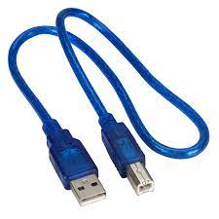

3.Ultrasonic sensor

***The ultrasonic sensor can be used to detect the presence of waste in the system. It emits an ultrasonic pulse and then measures the time it takes for the pulse to return. The distance to the waste can be calculated based on the time of flight of the pulse.***

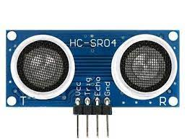

4.Infrared sensor

***The infrared sensor can be used to detect the type of waste. It emits an infrared beam and then measures the amount of infrared light that is reflected back. The type of waste can be inferred based on the amount of infrared light that is reflected back.***

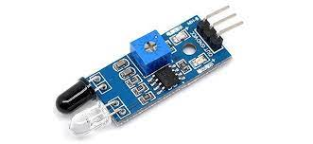

5.Moisture sensor

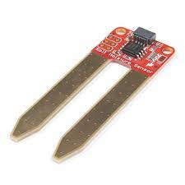

***The moisture sensor can be used to detect whether the waste is wet. It measures the electrical conductivity of the waste, which is higher when the waste is wet.***

6.Metal sensor

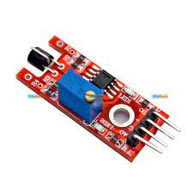

***The metal sensor can be used to detect whether the waste is metallic. It emits a magnetic field and then measures the strength of the magnetic field. The presence of metal in the waste will cause the strength of the magnetic field to change.***

7.Servo motor

***The servo motor can be used to open and close the doors to the different waste bins. It is a rotary actuator that can be controlled to rotate to a specific angle.***

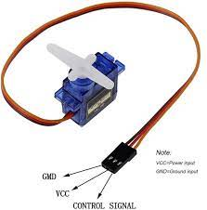

8. Motor driver circuit

***The motor driver circuit is used to control the speed and direction of the servo motor. It is a power amplifier that can increase the current output of the Arduino board to drive the servo motor***

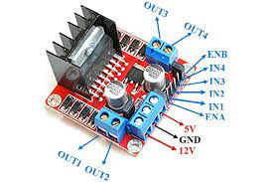

9.LCD

.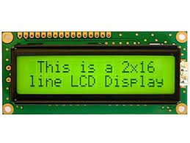

***The LCD could be used to display the type of waste that is being segregated.***

10. Load Cells

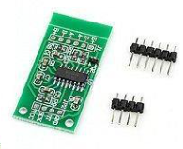

***This can be used to measure the weight of the waste in the waste bins***

11.Microcontroller

***The microcontroller is the main controller for the system. It is responsible for reading the sensor data, controlling the actuators, and displaying information on the LCD.***

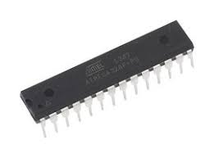

12.Enclosure for Arduino Uno

***The enclosure for the Arduino Uno is used to protect the Arduino board from the elements. It is especially important to protect the Arduino board from moisture and dust in an automated waste segregation system.***

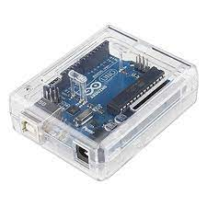

13.Power supply

***The power supply is needed to power the Arduino board and the other components in the system. The power supply could be a wall adapter or a battery pack***

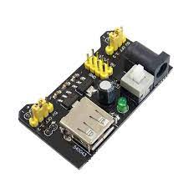

14. Bins and containers

***The bins and containers are used to store the segregated waste. The bins and containers should be labeled to indicate the type of waste that is supposed to be placed in each bin or container.***

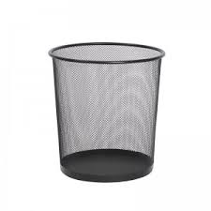

**Code for this components**

* 1. **Ultrasonic Sensor**
* #include <Servo.h>   //servo library
* Servo servo;
* int trigPin = 5;
* int echoPin = 6;
* int servoPin = 7;
* int led= 10;
* long duration, dist, average;
* long aver[3];   //array for average
* void setup() {
* Serial.begin(9600);
* servo.attach(servoPin);
* pinMode(trigPin, OUTPUT);
* pinMode(echoPin, INPUT);
* servo.write(0);         //close cap on power on
* delay(100);
* servo.detach();
* }
* void measure() {
* digitalWrite(10,HIGH);
* digitalWrite(trigPin, LOW);
* delayMicroseconds(5);
* digitalWrite(trigPin, HIGH);
* delayMicroseconds(15);
* digitalWrite(trigPin, LOW);
* pinMode(echoPin, INPUT);
* duration = pulseIn(echoPin, HIGH);
* dist = (duration/2) / 29.1;    //obtain distance
* }
* void loop() {
* for (int i=0;i<=2;i++) {   //average distance
* measure();
* aver[i]=dist;
* delay(10);              //delay between measurements
* }
* dist=(aver[0]+aver[1]+aver[2])/3;
* if ( dist<50 ) {
* //Change distance as per your need
* servo.attach(servoPin);
* delay(1);
* servo.write(0);
* delay(3000);
* servo.write(150);
* delay(1000);
* servo.detach();
* }
* Serial.print(dist);
* }
  1. **Moisture and Metallic Sensor**

1. #include <Arduino.h>
2. // Define the pins for the waste bins
3. const int BIN_1_PIN = 2; // Dry waste
4. const int BIN_2_PIN = 3; // Wet waste
5. const int BIN_3_PIN = 4; // Metallic waste
6. // Define the pin for the moisture sensor
7. const int MOISTURE_SENSOR_PIN = 6;
8. // Define the pin for the metal detector sensor
9. const int METAL_DETECTOR_SENSOR_PIN = 7;
10. void setup() {
11. // Set the pins for the waste bins as output
12. pinMode(BIN_1_PIN, OUTPUT);
13. pinMode(BIN_2_PIN, OUTPUT);
14. pinMode(BIN_3_PIN, OUTPUT);
15. // Set the pins for the sensors as input
16. pinMode(MOISTURE_SENSOR_PIN, INPUT);
17. pinMode(METAL_DETECTOR_SENSOR_PIN, INPUT);
18. }
19. void loop() {
20. // Read the value of the moisture sensor
21. int moistureSensorValue = analogRead(MOISTURE_SENSOR_PIN);
22. // Read the value of the metal detector sensor
23. int metalDetectorSensorValue = digitalRead(METAL_DETECTOR_SENSOR_PIN);
24. // Check if the waste is wet
25. if (moistureSensorValue> 500) {
26. // Turn on the wet waste bin
27. digitalWrite(BIN_2_PIN, HIGH);
28. // Turn off the other waste bins
29. digitalWrite(BIN_1_PIN, LOW);
30. digitalWrite(BIN_3_PIN, LOW);
31. }
32. // Check if the waste is metallic
33. else if (metalDetectorSensorValue == HIGH) {
34. // Turn on the metallic waste bin
35. digitalWrite(BIN_3_PIN, HIGH);
36. // Turn off the other waste bins
37. digitalWrite(BIN_1_PIN, LOW);
38. digitalWrite(BIN_2_PIN, LOW);
39. }
40. // Else, the waste is dry
41. else {
42. // Turn on the dry waste bin
43. digitalWrite(BIN_1_PIN, HIGH);
44. // Turn off the other waste bins
45. digitalWrite(BIN_2_PIN, LOW);
46. digitalWrite(BIN_3_PIN, LOW);
47. }
48. // Wait for a short period of time before checking the sensors again
49. delay(100);
50. }

**Block Diagram**



References

1. <https://www.arduino.cc/reference/en/>
2. <https://docs.arduino.cc/built-in-examples/>
3. <https://www.semanticscholar.org/paper/IoT-Based-Automated-Waste-Segregator-for-Efficient-Saminathan-Musipatla/c05ed54e512f6b8dcd1baa56227ca5cf7a40356f>
4. <https://www.semanticscholar.org/paper/MICROCONTROLLER-BASED-WASTE-SEGREGATOR-AND-OF-WET-Nandini-Chaitra/2eca8c6c1bc668c6f495973c1c09be94af4d53cf>
5. <https://www.semanticscholar.org/paper/Implementation-of-an-Automatic-Waste-Segregator-Uno-Sunehra-Pravalika/ffaf2a946e0dda64b044d27d1e2f9e289fc62848>
6. <https://www.semanticscholar.org/paper/IoT-based-Automatic-Waste-segregator-Lopes-Machado/41f044c59bf3b291775c5bfb0a63a47ab0e6e006>
7. <https://www.semanticscholar.org/paper/AUTOMATED-WASTE-SEGREGATOR-Gimonkar/4fb45fa1b2072953d621277ec52932f81eeac3cc/figure/6>